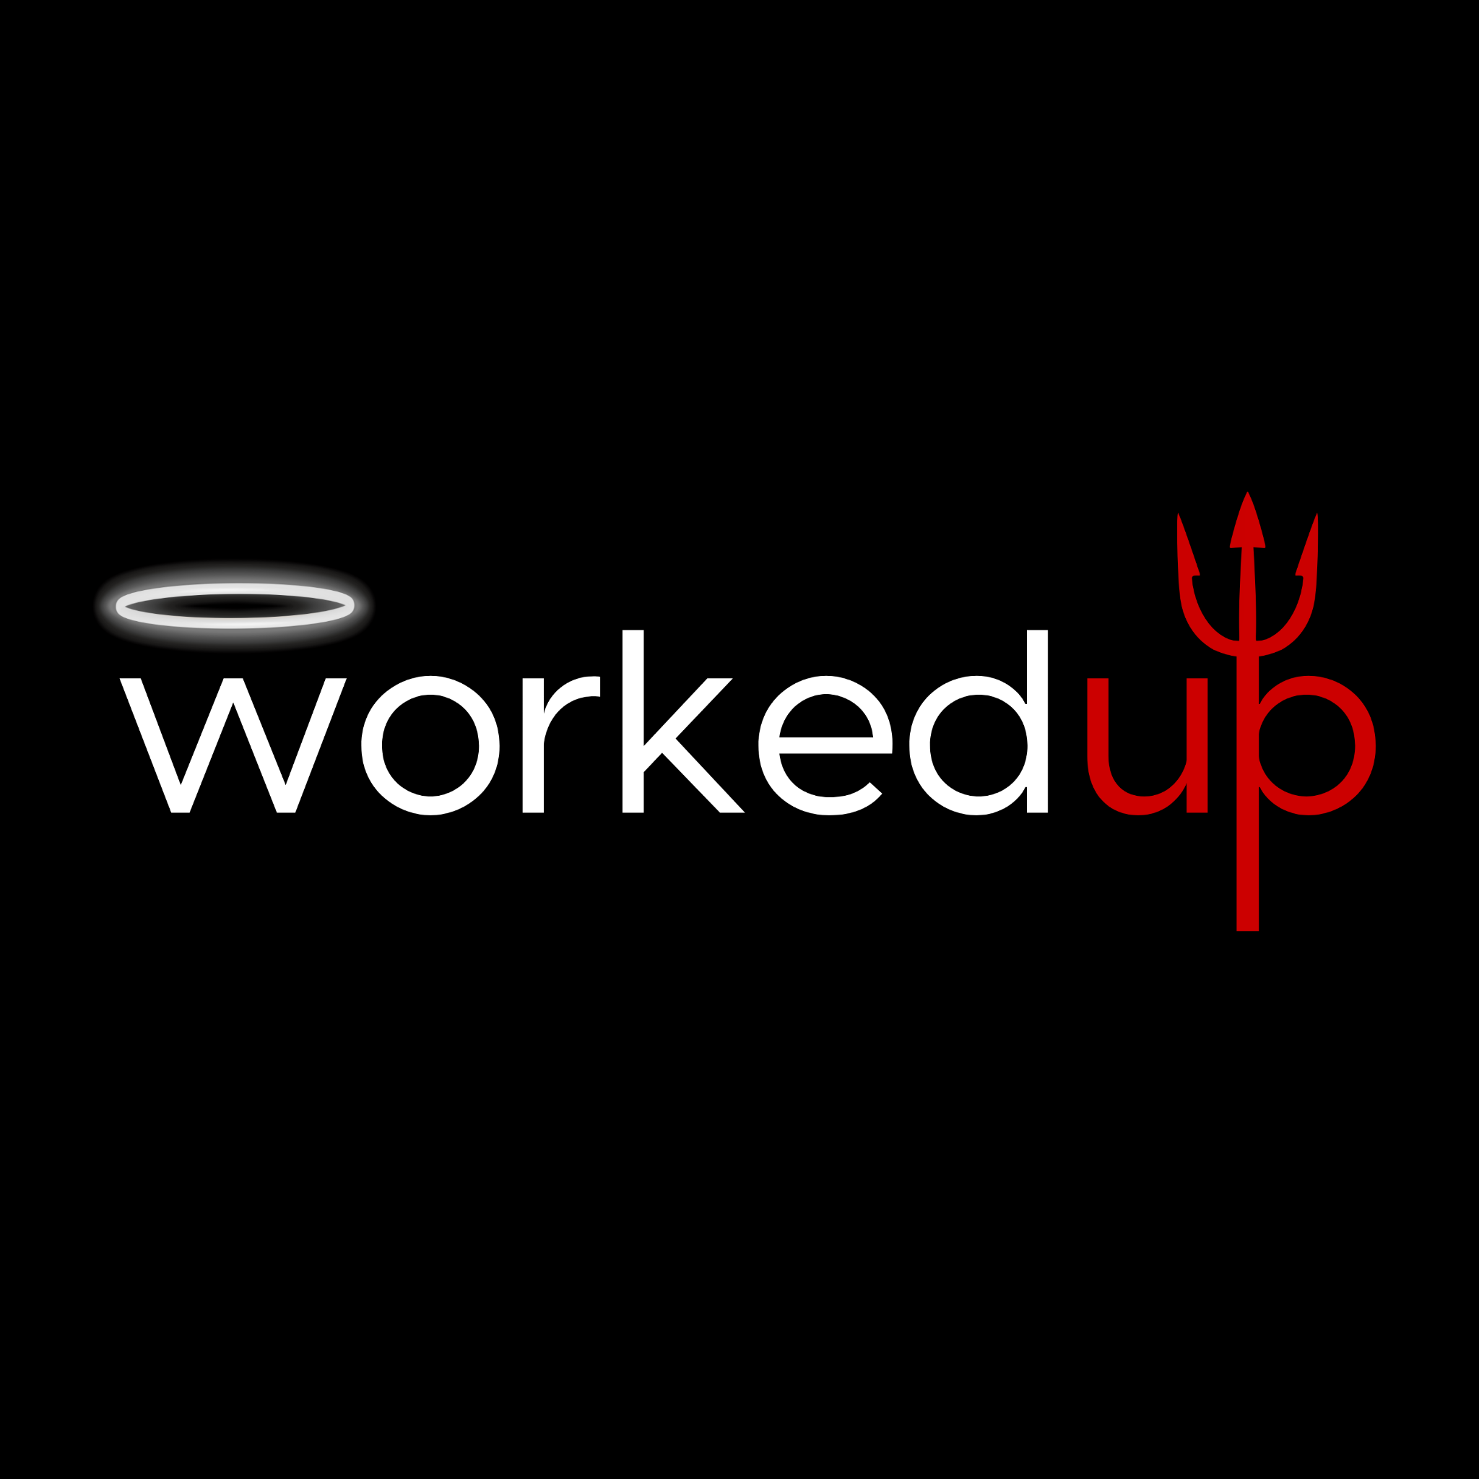INTERVIEW
PREPARATION
PLANNER
Prepare the things you want to say,
the examples you want to use and the
questions you want to ask — so you can
focus on having a good conversation.

Brought to you by
able recruitment

PAGE 1

DO YOUR HOMEWORK
1 RESEARCH THE COMPANY
You don't need to memorise the entire website. Focus on understanding the organisation, the role and what matters to you.
What does the company do?

___________________________________________________________________________________________________
What have I learned about the role and team?

___________________________________________________________________________________________________
What interests me about this opportunity?

___________________________________________________________________________________________________
Is there anything else I want to know more about?

___________________________________________________________________________________________________
2 RESEARCH THE INTERVIEWER
Knowing who you're meeting can help you understand their perspective and prepare for the conversation.
Who am I meeting and what is their role?

___________________________________________________________________________________________________
Is there anything useful or relevant I know about their background?

___________________________________________________________________________________________________

PAGE 2

PREPARE YOUR KEY TALKING POINTS
3 KEY ACHIEVEMENTS I WANT TO DISCUSS
Don't leave your best experience to chance. Think about the things you want the interviewer to know about you.
What am I most proud of?

___________________________________________________________________________________________________
What results or outcomes have I achieved?

___________________________________________________________________________________________________
What strengths or experience are particularly relevant to this role?

___________________________________________________________________________________________________

4 EXAMPLES I CAN USE
You don't need a perfectly rehearsed answer for every possible question. Prepare a bank of real examples you can draw on.
Think of an example of... | My example
An achievement I'm proud of
A problem I solved
A difficult situation or challenge
A time I took initiative
Working successfully with others
A mistake or something I learned from
*For each example, be ready to explain: What happened? What did you do? What was the outcome?

PAGE 3

QUESTIONS AND FINAL PREPARATION
5 QUESTIONS I WANT TO ASK
An interview is also your opportunity to decide whether the role is right for you.
What do I genuinely want to know about the role, team or organisation?

___________________________________________________________________________________________________
6 LOGISTICS CHECKLIST
□ | Confirm the date and time
□ | Check the location, travel time or meeting link
□ | Know who I'm meeting
□ | Re-read the job advertisement or position description
□ | Review my CV
□ | Test my camera, microphone and internet if interviewing online. Make sure Teams, Zoom, Google meet etc is downloaded if necessary.
□ | Choose what I'm wearing
□ | Allow extra time so I'm not rushing
★ FINALLY
What are the three things I most want the interviewer to remember about me?
1. ________________________________________________________________________________________
2. ________________________________________________________________________________________
3. ________________________________________________________________________________________

